Renovating Dwellings for Basic Access: A Guide for Construction Professionals

©2013, Eleanor Smith and the Statewide Independent Living Council of Georgia

Introduction
Most people who develop difficulties in walking (mobility impairments) are formerly non-disabled people who develop impairments through an accident, illness, or aging. At that point, a situation often arises that deeply impacts their lives: they find they cannot use their own dwelling safely, nor visit in the dwellings of most of their friends and extended family. This population includes not just wheelchair users, but also those who use walkers, canes, or other mobility devices, or have poor balance, weakness or stiffness---in all, a large population. (Research predicts that 60% of all dwellings built in the year 2000 will have, at some point during the lifetime of the dwelling, a resident with severe, long-term mobility impairment.) Thus, when a dwelling is being renovated, whenever basic access features can be incorporated without undue difficulty or expense, and with aesthetic appeal, to do so is humane, fiscally wise for society in general, and potentially more profitable for the developer because the houses can be marketed to a larger group.
Some dwellings designated for renovation, and intended for the general public, are not appropriate for renovation for basic disability access because of their physical characteristics, while other dwellings are appropriate. Obviously there are certain sites that present obstacles to having a zero step entrance, such as very short set-back from the street, obstruction from a large tree or retaining wall or other situation. These guidelines are intended to help the renovator:
- Identify which dwellings are appropriate.
- Apply the access features to appropriate dwellings.
Note: All information throughout this document is intended for renovations which are NOT required by a law or policy to incorporate access features. In cases where access is in fact required by law or policy-- for example in some units where government financial assistance is used--very specific construction requirements apply. The information in this document is intended to be a more fluid, practical, voluntary approach which can be very helpful to residents and visitors with disabilities and, at the same time, assets for general non-disabled buyers or renters.
The essential basic access features to be incorporated in dwellings deemed appropriate:
--At least one entrance without any steps approachable by a firm surface no steeper than 1:12
--All interior passage doors on the main floor, including the door to the largest main floor bathroom, with a clear passage space of at least 30 inches (preferably 32 or 34 inches) when the door is open at 90 degrees.
Why these features? While entering a dwelling and fitting through the doors are not the only features that may be helpful or needed by a specific person with a mobility impairment, they are the two most essential ones. (For instance, they are the most crucial features for people to return to their own home from a hospital after a mobility-related injury.) These features provide a base which permits many visitors and residents with mobility impairments to use the dwelling. At the same time they are convenient for non-disabled people and can be incorporated in an aesthetically attractive way in appropriate houses.
Thumbnail Summary of the Physical Characteristics of a Dwelling Appropriate for Basic Access:
--The unrenovated dwelling currently has one entrance at the front, side, or back that is not more than 16 inches above grade (i.e., not more than two steps) OR has an attached garage in which the step from the garage into the dwelling is not more than 6 inches high.
--The step from the porch or stoop at this entrance is not more than 4 inches high. (See Q and A)
--The dwelling has a full bathroom on the main level.
--The halls on the main level are at least three feet wide.
--There is at least one bedroom on the main level, or a room such as a den that could serve as a bedroom.
Please note the handy checklist provided at the end to help you get all needed measurements.
Important notes re adding zero-step entrances to existing homes:

- The route to the zero-step entrance should not be steeper than 1:12—that is, the route should be a foot or longer for every inch in height it must rise. This is an 8.3 % maximum grade. (If the starting point of a slope is relatively high, shorter slopes can still achieve the 8.3% maximum grade.)

- In most cases. the zero-step entrances on appropriate dwellings will be sidewalks, accomplished by grading the earth so that a sidewalk ties directly into a porch or stoop. “Ramps”, as opposed to sidewalks, are generally not required. (Throughout this document, the word “ramp” is used with the common meaning of a sloping structure with 90-degree drop-offs at the edges, typically with handrails along the sides.)

- Even if a driveway is much steeper than 8.3%, a useful zero-step entrance can be created leading from the top of the driveway to the dwelling, provided that there is a nearly level parking pad at the top of the driveway. See the example below showing a useful entrance at the top of a steep driveway.
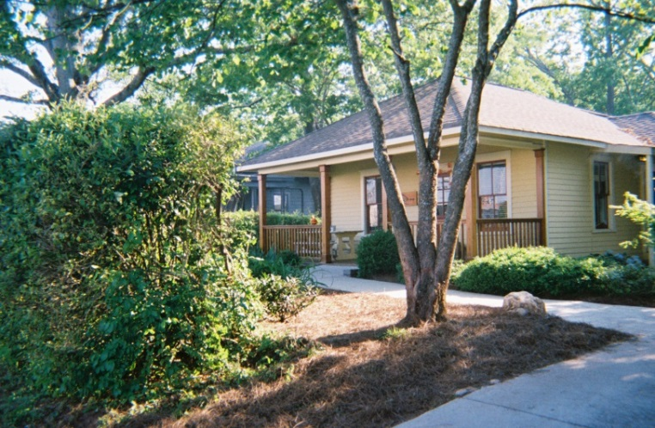 Single-story house with sidewalk leading to step-less front entry

- If a “ramp” per se is used, as opposed to a sidewalk or other surface without major drop-offs at the edges, the ramp MUST follow code.

ENTRANCES --

- Construction Options for Creating a Zero –step Front Entrance on a Renovated Dwelling:
(These options are based on the assumption that a non-disabled buyer or renter is generally not attracted by a ramp extending directly forward from the front door.)
Option A. Fill Dirt which permits a sidewalk to tie directly in to the porch or stoop. This dirt may be taken from the site itself, or brought in. See the two examples below:
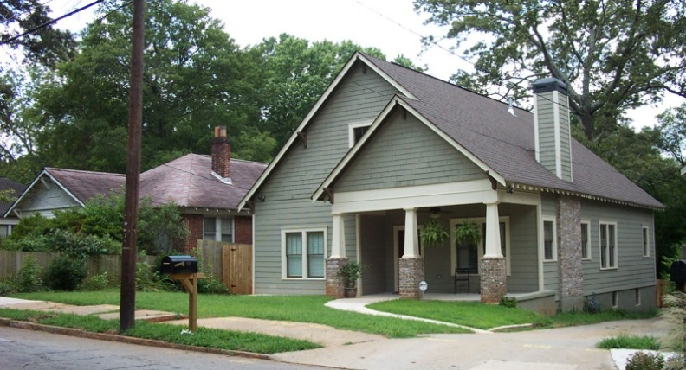 Two-story house, sidewalk leading to step-less porch and front entry.
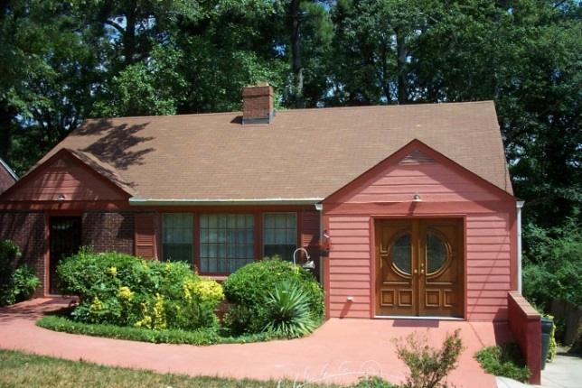 Single-story house, sidewalk that ties directly to porch
Option B. . Sometimes the porch is so close to grade that no fill dirt or added grading is necessary. A thickened sidewalk segment is created so that the sidewalk ties to the porch. See the two examples below:
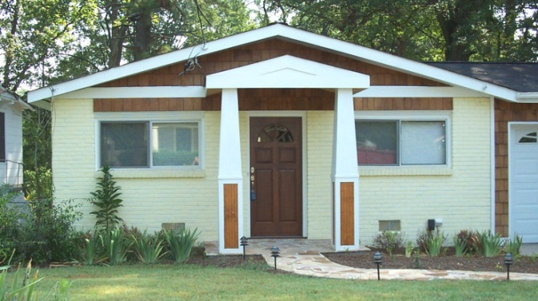 Single-story house, with thickened sidewalk segment tying to porch
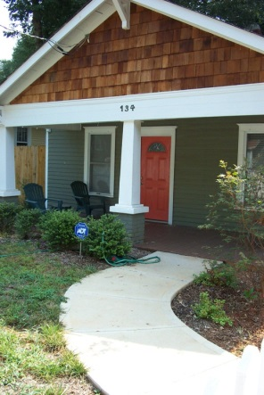 Single-story house, thickened sidewalk creating step-less porch

Option C. The zero-step entrance ties into the side of the front porch and runs parallel to the front face of the dwelling. Landscaping such as bushes can be installed near the edge of the ramp or sloped sidewalk to soften the appearance. To achieve this option, existing bushes can be removed from the area adjacent to the foundation of the dwelling; the sidewalk --or a ramp—then constructed; and then new landscaping installed along the ramp or sidewalk. See the two examples below:
.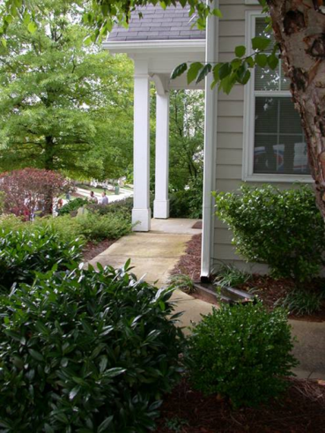 House with side entry ramp leading to front porch
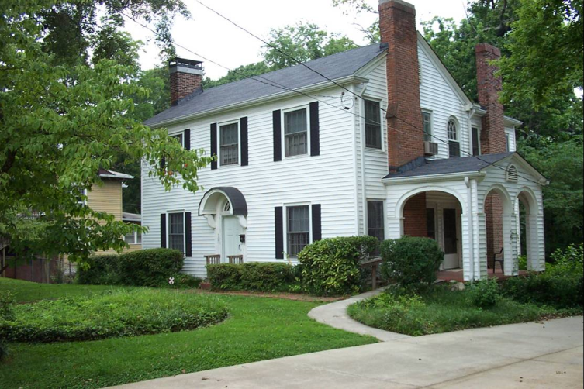 Two-story house, sidewalk leading to zero-step side entrance
- Construction Options for Creating a Zero –Step Side Entrance on a Renovated Dwelling:

Option A: Fill dirt, or thickened sidewalk segment, permitting a sidewalk tying into a side porch or stoop: The sidewalk may run from the front of the property toward the back, or from the back toward the front, depending on the characteristics of the lot. See the example below:

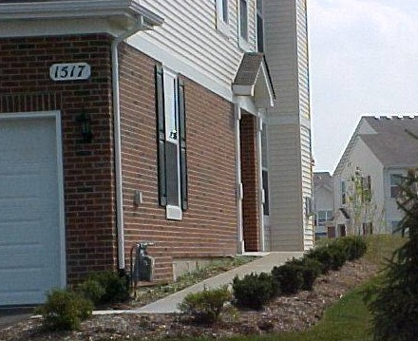 Two-story house, fill dirt under sidewalk tying to side porch
Option B: A ramp per se. A ramp, while not usually considered attractive to the non-disabled buyer or renter if it extends forward from the front door of the dwelling, is more readily acceptable if it runs along the side, particularly if it does not extend beyond the front face of the dwelling. In the case below, the residents find the ramp an asset for rolling the trash receptacle to the curb. Obviously if a resident or visitor in that home needed the ramp in order to enter the home, the trash receptacle would not be kept on the porch.
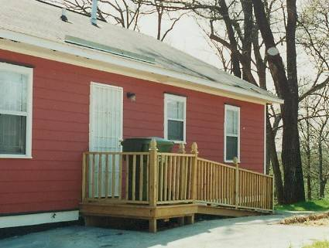 Single-story house, wooden ramp accessing side entrance

- Construction Options for Creating a Zero –Step Back Entrance on Renovated Dwellings:
Any of the methods described earlier can be used to create an entrance at the back: fill dirt, thickened sidewalk segments, or ramps per se. The entrances may proceed from an alley, an existing sidewalk or a driveway. See the examples below:
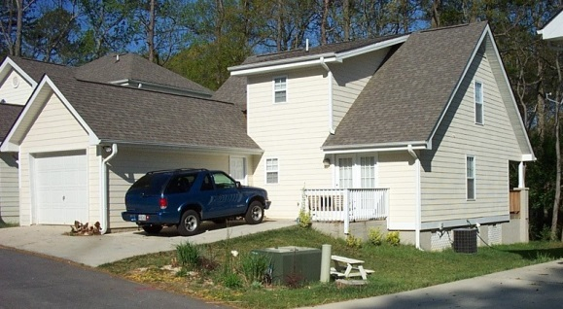 Attached two-story, zero step rear entry
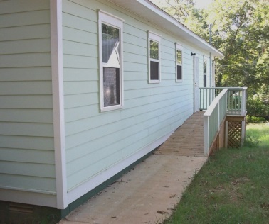 Ramp with handrails, accessing back entrance
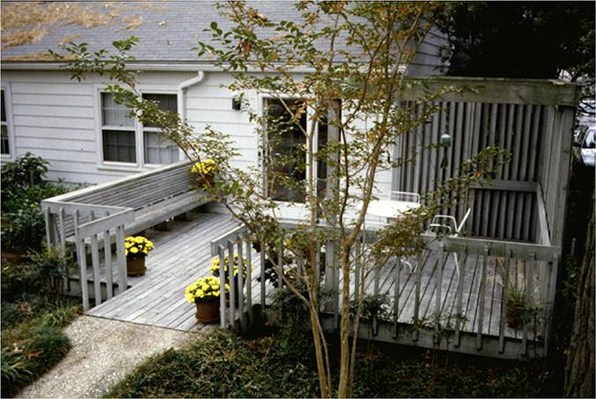 No-step back entrance, thickened ramp segment

- Construction Options for Creating a Zero –Step Entrances from Attached Garages of Renovated Dwellings:

A key question: Is the height of the step from the garage to the interior of the house 6 inches or less?
This question is important because, although most general renters or buyers will not want a long ramp in the garage taking away space for vehicles or storage, a short ramp will be acceptable and may be seen as an amenity for bringing items from the garage into the house. (Note: If the door leading into the house is exceptionally narrow and not amenable to widening, there is no point in creating a ramp. See the section on Doors.)

A step inside the garage with a height of 6 inches or less does NOT need to follow the 1:12 maximum steepness standard because wheelchairs, crutches, etc. are not likely to veer out of control with such a low rise. However, the ramp cannot be of unlimited steepness. Following are guidelines for the length of ramp needed for a low rise:
½ inch rise -- no ramp needed
1 inch rise - base of ramp can be as short as 4 inches
2 inch rise - Base of ramp can be as short as one foot
3 inch rise - Base of ramp can be as short of 18 inches
4 inch rise - Base of ramp can be as short as two feet
5 inch rise - Base of ramp can be as short as 34 inches
6 inch rise - Base of ramp can be as short as four feet
(Beyond a 6 inch rise, the 1:12 standard should be used in order to have safe slopes.)

The ramp in the garage, like all ramps, should be level side to side. If made of concrete or other molded substance, care should be taken to ensure the surface is flat top to bottom (not ‘humped’ or ‘scooped’ at any point). It should end in a drop-off of ½ inch or less.

The door leading from the garage into the house should provide a minimum of 30 inches of clear passage space; if not, there is no point in creating a ramp. There should either be a code-compliant rail, or else the width of the ramp should extend several inches beyond the width of the door. See the example below, shown in mid-construction:

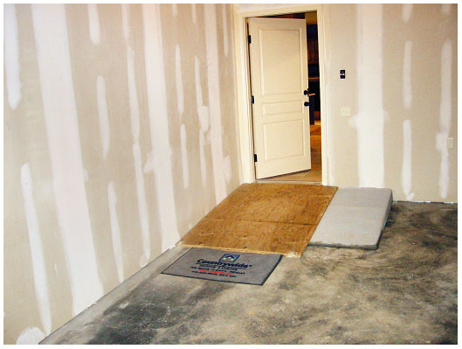 Garage entrance, extended ramp creating step-less entry into house

INTERIOR DOORS, HALLS AND BATHROOMS
Achieving a minimum of 30 inches of clear passage space in passage doors.
A passage door is one that leads into a room such as a bedroom or bathroom, and does not include coat closets, linen closets, water heater closets, etc.
As noted earlier, all interior passage doors on the main floor, including the door to the largest main floor bathroom, should provide a clear passage space of at least 30 inches (preferably 32 or 34 inches) when the door is open at 90 degrees. The arrow below indicates the passage space of a door open at 90 degrees.
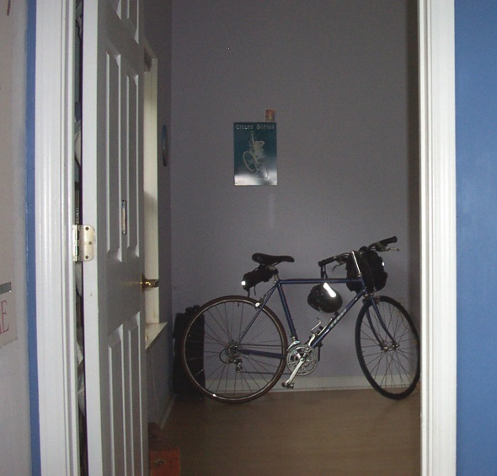 Interior doors opened at 90 degrees allows for 30 inches of passage space
Most existing houses lack bathroom doors with 30 inches or more of clear passage space. However, many narrow doors are amenable to reasonably cost-effective modification.
When is it practical to modify an existing narrow door to achieve 30 inches or more of clear passage space?
A rule of thumb is, if a wall needs to be moved to achieve the needed width, it is not cost-effective to widen the door. But in the great majority of cases a wall does not have to be moved. The existing wall beside the door usually provides space for the door to be widened. See the example below of extra wall space that can be used for a wider door.
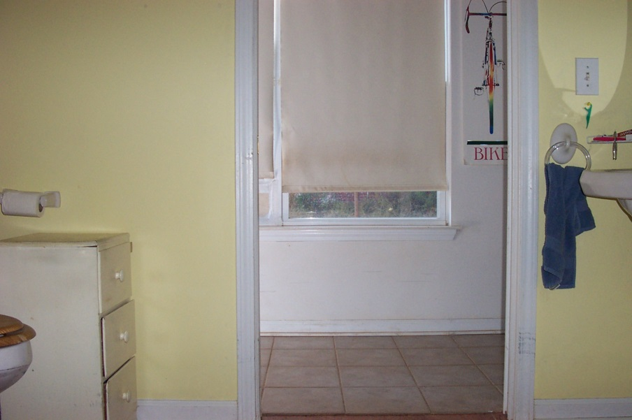 Bathroom door entrance illustrates how extra wall space can be used for widening door
Free wall space at the right of the door trim Is 5” if towel ring is moved.

Free wall space at the left of the door trim is more than 12”

inches

Gaining 1 ½ to 2 inches by installing swing-away hinges.
If a bathroom or bedroom door lacks only an inch and a half to two inches of achieving the needed passage space, a set of swing away hinges can be installed.
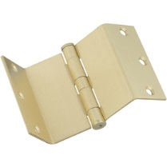 Swing away hinge (Available through the Internet or at home improvement stores. These hinges allow the door to be opened 180 degrees rather than 90 degrees when swinging space allows – gaining two to three inches on door width.
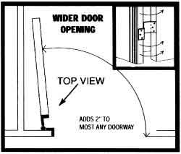 Illustration of an interior door utilizing a swing away hinge
Swing away hinges can be ordered through the internet, and they are increasingly available in home improvement stores like Lowe’s and Home Depot. Essentially, these hinges allow the door to be opened 180 degrees rather than 90 degrees when swinging space allows. They are often more practical for gaining space through bedroom doors than bathrooms because of the swing space required.
Gaining Added Maneuvering Room within the Bathroom
Added maneuvering space can be gained by swinging the door outward (first Diagram below) or installing pocket door (second Diagram).
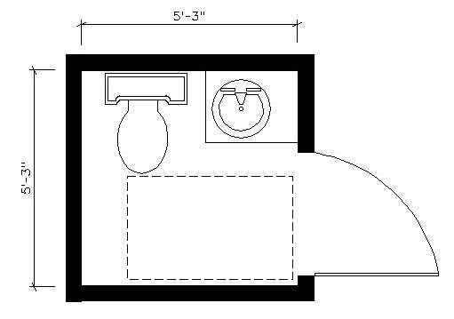 Diagram of a half-bathroom with swing-out door, which allows wheelchair user space to get in, close door and use facilities.
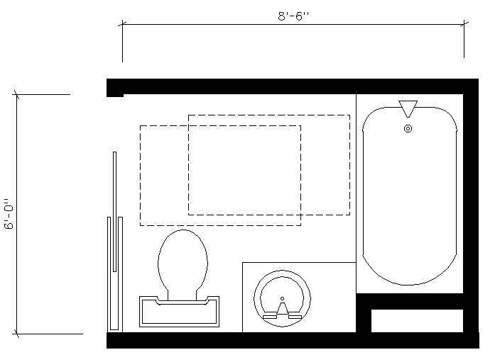 Diagram of accessible bathroom utilizing a pocket door
Hall Width
For practical access for a wheelchair (or a TV cart, furniture or other large items) to turn into a room from a hall, a hall at least 36 inches wide is needed, just as a car needs a lane wider than itself in order to make a turn. Fortunately, most existing houses have halls at least 36 inches wide.
A wheelchair-sized template for assessing feasibility of turns.
To determine whether a standard adult wheelchair could make unusual turns such as doglegs in halls etc., it can be helpful to cut a 30 inch by 48 inch rectangle and slide it along the floor through the space. This size rectangle is in common use as the basic dimension of a standard wheelchair, and includes room for the users’ toes sticking out over the footplates and fingers gripping the wheel rims.
Interior Features for When a Renovated Dwelling is Gutted
When a dwelling is gutted, there is opportunity to include several useful interior features which are not practical when the existing walls are left intact. In gutted dwellings, a good guideline is to include the features listed in the Fair Housing Act: not only zero-step entrances and sufficiently wide halls and doors, but reachable placement of outlets and light switches; basic maneuvering space in bathrooms and kitchens; and blocking in bathroom walls at the tub, toilet or shower so that grab bars could be added at a later time if needed without having to remove drywall for reinforcement. These features are very inexpensive in new construction or gutted interiors. The guidelines have been required for new, multi-family housing of four or more units since 1991, whether publicly or privately financed and whether for rent or for sale. The features are required in all ground floor units if there is no elevator and in all units of every floor if there is an elevator. The “Fair Housing Act Design Manual” with extensive, clear illustrations, is available free online and in print for $5 from HUD at: http://portal.hud.gov/hudportal/HUD?src=/program_offices/fair_housing_equal_opp/disabilities/fhefhag

Lowe’s has an “Accessible Home” section of its website with many useful accessibility products. See: http://www.lowes.com/Accessible-Home/_/N-1z0x54v/pl?storeId=10151&langId=-1&catalogId=10051

Other excellent resources for design, discussion and training about basic access and making dwellings “visitable” for all are available for free at : www.concretechange.org
Q and A:
- Is it worth it to renovate a two story house for basic access when there is no access to the upper floor?
Yes. Many people with disabilities or older people are members of households with other relatives or friends; others may live alone but want space for a caregiver. Access to a second floor (or basement) for a person with mobility impairment is nice but not crucial. What is crucial is the ability to live safely in one’s home and visit the homes of friends and extended family.
- Why does the template indicate a maximum 6 inch step from the garage into the dwelling but a maximum 4 inch rise from a porch into the dwelling?

Because a garage is large enough to permit a longer ramp, whereas most porches are relatively shallow. On a porch, the slope leading from inside the dwelling onto the porch must lead to a level area on the porch at least 40 inches deep so that a wheelchair user exiting the dwelling can land on the level space before proceeding off the porch.

- What about additional features such as roll in showers, lowered kitchen cabinets, higher toilets and so on?
Ample doors and zero-step entrances are necessities for all people with mobility impairments, they are amenities for non-disabled people, and when done in the renovation process can be low-cost. The same cannot be said for adding roll-in showers, lower cabinets, higher toilets, etc. in renovations. Further, not all mobility impaired people want these additional items: some do not cook; some prefer baths to showers; some are short stature and cannot use a high toilet, and so on. These items may be needed by a specific individual, and thus worth the added cost for in a specific dwelling designated for that individual--- but not for general renovations in projects involving dozens or hundreds of dwellings for the general public, which is the topic of this document.
- Why does this document call for 30” minimum clear passage space when some standards, including the Fair Housing Act, call for 32”?
This document indicates a 30” minimum because it concerns renovation, when a 32 inch clear door may or may not be possible to install in the space available. While 30 inches does not work for some wheelchair users, it is usable for most. It is very frustrating to be unable to enter a bathroom, while looking around the door reveals space for a wider door. Inability to enter bathrooms leads to embarrassment, bladder and kidney problems from chronic postponing of using the bathroom and isolation for those who stay home rather than encountering these situations.
5) Why avoid terms like “wheelchair”, “disability”, etc., when marketing the dwellings?
- because (a) the dwellings renovated to contain a zero-step entrance and wide doors are intended for everyone (b) specialized terms might not appeal to some general buyers/renters (c) terms such as these might imply legal or code requirements which the renovator is in fact not obligated to follow in these voluntary projects (d) terms such as these might imply that the features will work for all people with mobility impairments, when in fact they will not work for all, but will for the great majority.

- Better terms to use are “zero-step entrance”, “accessible dwelling” and “ample interior doors”. Marketing terms such as “convenient”, “spacious”, etc. are also appropriate in conjunction with the features. These terms rightly imply convenience for all, and can be considered amenities. The terms “zero-step entrance” and “wide doors” are merely descriptive and do not signify dwellings designated for older or disabled people. The plainly-named access features will not go unnoticed by prospective buyers/renters whose households already include disabled or older members or who want to host guests with mobility impairments.

Checklist for Evaluating the Appropriateness of a Dwelling for Renovations for Access.
- Date of Evaluation: Name of Evaluator:

- ADDRESS of Dwelling:

- Does the dwelling already have an entrance with two or fewer steps at the front, side OR back—OR an attached garage with a step 6 inches high or less into the dwelling? Yes no

- Does the dwelling have a full bathroom on the main floor? Yes no

- Does the dwelling have a bedroom on the main floor, or a room such as a den that could serve as a bedroom? Yes No

- Is the hall on the main floor at least three feet wide? Yes No
IF NO to Number 3, 4, 5 OR 6 above, this particular dwelling is probably not amenable to practical, cost-effective incorporation of basic access features. If YES to 3,4,5, and 6, continue with the following evaluation questions.
- With regard to entrances, please answer a. through d. below
- Is there a front entrance with less than 2 steps to the porch or stoop? Yes no
- Is there a back entrance with less than 2 steps to the porch or stoop yes no
- Is there a side entrance with less than 2 steps to the porch or stoop yes no
- Is there an attached garage with a step no higher than 6 inches leading into the dwelling yes no

- Where, in your view, is the best location to create a zero step entrance on this particular property?
Put #1 by the best location. If another location is also good, put #2 by it.

Front Back Side Through Attached Garage

Now check the height of the step INTO the dwelling FROM the porch or stoop of your best location(s) A. through C. Is the height into the house 4 inches or less on at the location you have chosen as best ? Yes No On the location you have designated as second best? Yes No
If so, a zero-step entrance can probably be incorporated using one of the methods described on the following pages.

Write any Additional Comments re the entrance(s) below or on the back:

”Aging and Disability: Implications for the Housing Industry and Housing Policy inthe United States,“ S.K. Smith, S. Rayer, E. Smith, Journal of the American Planning Association, Summer 2008

